SI Prefixes
# Source: AI Source: Provided by: [Data Path: Persons Table -> ID Column: 1, Name_En Column: Motasem Essam] -> From: [ChatGPT] on [7/17/2026]
SI Prefixes are standardized prefixes defined by the International System of Units (SI) to represent decimal multiples and submultiples of measurement units. They make it easier to express very large or very small quantities without writing many zeros.
SI prefixes are used with SI units such as the meter (m), gram (g), second (s), watt (W), volt (V), byte (B), and many others.

Definition
# Source: AI Source: Provided by: [Data Path: Persons Table -> ID Column: 1, Name_En Column: Motasem Essam] -> From: [ChatGPT] on [7/17/2026]
SI Prefixes are prefixes added to SI units to indicate multiplication or division by powers of ten.
Example:
- 1 kilometer (km) = 1,000 meters
- 1 millimeter (mm) = 0.001 meter

Purpose
# Source: AI Source: Provided by: [Data Path: Persons Table -> ID Column: 1, Name_En Column: Motasem Essam] -> From: [ChatGPT] on [7/17/2026]
SI prefixes are used to:
- Simplify numerical expressions.
- Avoid long strings of zeros.
- Standardize scientific and engineering measurements.
- Improve readability.
- Reduce calculation errors.
- Facilitate international communication.

SI Prefix Table
# Source: AI Source: Provided by: [Data Path: Persons Table -> ID Column: 1, Name_En Column: Motasem Essam] -> From: [ChatGPT] on [7/17/2026]
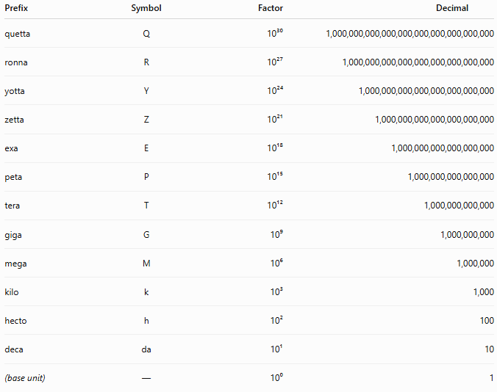
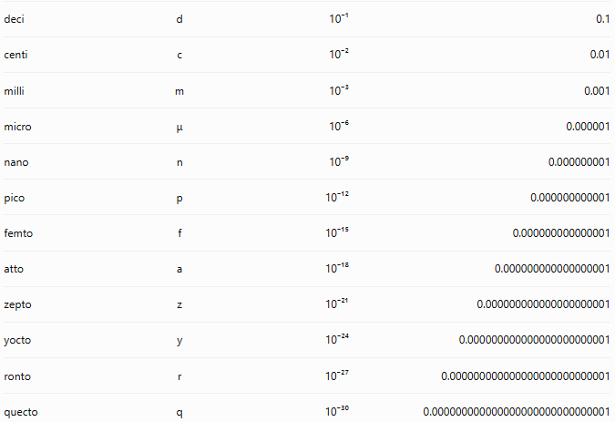
Prefix | Symbol | Factor | Decimal
quetta | Q | 10³⁰ | 1,000,000,000,000,000,000,000,000,000,000
ronna | R | 10²⁷ | 1,000,000,000,000,000,000,000,000,000
yotta | Y | 10²⁴ | 1,000,000,000,000,000,000,000,000
zetta | Z | 10²¹ | 1,000,000,000,000,000,000,000
exa | E | 10¹⁸ | 1,000,000,000,000,000,000
peta | P | 10¹⁵ | 1,000,000,000,000,000
tera | T | 10¹² | 1,000,000,000,000
giga | G | 10⁹ | 1,000,000,000
mega | M | 10⁶ | 1,000,000
kilo | k | 10³ | 1,000
hecto | h | 10² | 100
deca | da | 10¹ | 10
(base unit) | — | 10⁰ | 1
deci | d | 10⁻¹ | 0.1
centi | c | 10⁻² | 0.01
milli | m | 10⁻³ | 0.001
micro | μ | 10⁻⁶ | 0.000001
nano | n | 10⁻⁹ | 0.000000001
pico | p | 10⁻¹² | 0.000000000001
femto | f | 10⁻¹⁵ | 0.000000000000001
atto | a | 10⁻¹⁸ | 0.000000000000000001
zepto | z | 10⁻²¹ | 0.000000000000000000001
yocto | y | 10⁻²⁴ | 0.000000000000000000000001
ronto | r | 10⁻²⁷ | 0.000000000000000000000000001
quecto | q | 10⁻³⁰ | 0.000000000000000000000000000001
Note: The prefixes quetta (Q), ronna (R), ronto (r), and quecto (q) were officially added to the SI in 2022 by the General Conference on Weights and Measures.

Commonly Used SI Prefixes
# Source: AI Source: Provided by: [Data Path: Persons Table -> ID Column: 1, Name_En Column: Motasem Essam] -> From: [ChatGPT] on [7/17/2026]
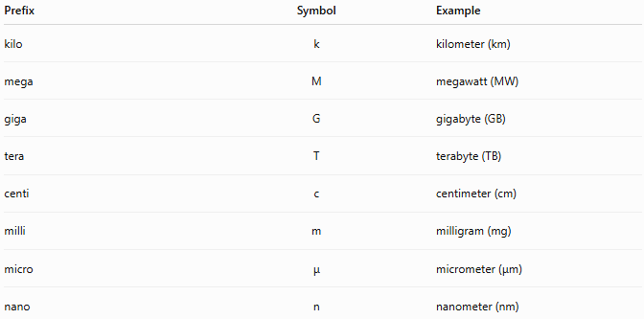
Prefix | Symbol | Example
kilo | k | kilometer (km)
mega | M | megawatt (MW)
giga | G | gigabyte (GB)
tera | T | terabyte (TB)
centi | c | centimeter (cm)
milli | m | milligram (mg)
micro | μ | micrometer (μm)
nano | n | nanometer (nm)

Examples
# Source: AI Source: Provided by: [Data Path: Persons Table -> ID Column: 1, Name_En Column: Motasem Essam] -> From: [ChatGPT] on [7/17/2026]
Length
- 1 km = 1,000 m
- 1 cm = 0.01 m
- 1 mm = 0.001 m
- 1 μm = 10⁻⁶ m
- 1 nm = 10⁻⁹ m

Mass
- 1 kg = 1,000 g
- 1 mg = 0.001 g
- 1 μg = 10⁻⁶ g

Time
- 1 ms = 0.001 s
- 1 μs = 10⁻⁶ s
- 1 ns = 10⁻⁹ s

Digital Storage (SI Usage)
- 1 kB = 1,000 bytes
- 1 MB = 1,000,000 bytes
- 1 GB = 1,000,000,000 bytes
Note: In computing, binary prefixes such as KiB, MiB, and GiB are also used and have different meanings.

Rules for Using SI Prefixes
# Source: AI Source: Provided by: [Data Path: Persons Table -> ID Column: 1, Name_En Column: Motasem Essam] -> From: [ChatGPT] on [7/17/2026]
- Use only one prefix with a unit.
  - ✔ km
  - ✘ mkm
- Write the prefix symbol directly before the unit symbol, with no space.
  - ✔ mm
  - ✘ m m
- Prefix symbols are case-sensitive.
  - M = mega (10⁶)
  - m = milli (10⁻³)

Applications
# Source: AI Source: Provided by: [Data Path: Persons Table -> ID Column: 1, Name_En Column: Motasem Essam] -> From: [ChatGPT] on [7/17/2026]
SI prefixes are widely used in:
- Physics
- Chemistry
- Engineering
- Electronics
- Medicine
- Computing
- Telecommunications
- Manufacturing
- Astronomy
- Nanotechnology

Everyday Examples
# Source: AI Source: Provided by: [Data Path: Persons Table -> ID Column: 1, Name_En Column: Motasem Essam] -> From: [ChatGPT] on [7/17/2026]
- Road distances → kilometers (km)
- Height measurements → centimeters (cm)
- Medicine doses → milligrams (mg)
- Internet speed → megabits per second (Mb/s)
- Computer storage → gigabytes (GB)
- Cell size → micrometers (μm)

Common Mistakes
# Source: AI Source: Provided by: [Data Path: Persons Table -> ID Column: 1, Name_En Column: Motasem Essam] -> From: [ChatGPT] on [7/17/2026]
- Confusing M (mega) with m (milli).
- Using multiple prefixes on the same unit.
- Mixing SI decimal prefixes with binary prefixes (kB vs. KiB).
- Forgetting that symbols are case-sensitive.

SI Prefixes vs. Scientific Notation
# Source: AI Source: Provided by: [Data Path: Persons Table -> ID Column: 1, Name_En Column: Motasem Essam] -> From: [ChatGPT] on [7/17/2026]
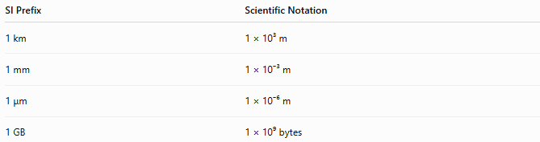
SI Prefix | Scientific Notation
1 km | 1 × 10³ m
1 mm | 1 × 10⁻³ m
1 μm | 1 × 10⁻⁶ m
1 GB | 1 × 10⁹ bytes

Key Points
# Source: AI Source: Provided by: [Data Path: Persons Table -> ID Column: 1, Name_En Column: Motasem Essam] -> From: [ChatGPT] on [7/17/2026]
- SI prefixes represent powers of ten.
- They simplify the expression of very large and very small quantities.
- Each prefix has a unique name, symbol, and power of ten.
- Prefix symbols are case-sensitive.
- Only one SI prefix should be used with a unit symbol.

Conclusion
# Source: AI Source: Provided by: [Data Path: Persons Table -> ID Column: 1, Name_En Column: Motasem Essam] -> From: [ChatGPT] on [7/17/2026]
SI Prefixes are standardized prefixes used with SI units to represent decimal multiples and submultiples based on powers of ten. They simplify the expression of measurements, improve readability, and provide a consistent international system for communicating quantities across science, engineering, medicine, industry, and everyday life. By replacing long strings of zeros with concise prefixes such as kilo (k), mega (M), milli (m), and micro (μ), SI prefixes make measurements easier to read, compare, and calculate.

